

House Rental Agreement

SULTANA NASRIN, Father: Siddikur Rahman, Mother: Lutfun Nesa, Address: Milton Miar Bari, Village/Road: Shobuj Gram, Post Office: Alekzander - 3730, Police Station: Ramgati, District: Lakshmipur. Religion: Islam, Nationality: Bangladeshi, National ID No- 5127306498835, Profession: Business.
First Party/Owner.

Haydar Paik, son of Mohabbat Paik, Permanent Address: Village- Fatehpur, Post Office: Fatehpur-9300, Bagerhat Sadar, Bagerhat. Nationality: Bangladeshi, Religion: Islam, Profession: Business. National Identify No.: 9107378607.

Second Party/Tenant.

Taking the name of the almighty Allah we like to start writing description of this rental deed for the below schedule Plot- 8072, Mouza: Krishnorampur, P.S- Sadar, Dist- Noakhali, We both the parties 1st and 2nd get agree to take and give the rent by maintaining the following terms & conditions.

Rules of Agreement
- The below schedule Flat made rented to the second party’s by the said 1st party’s for a period of 5 (Five) years. The period will be 27/10/2024 to 26/10/2029.
- Amount of Rent: monthly 95,000/- (Ninety Five Thousand) Tk, Rent to be payable between 1 to 5 date of every month.


- Rentee shall be responsible any damage, such as fittings, tiles etc.

Page 1 of 2

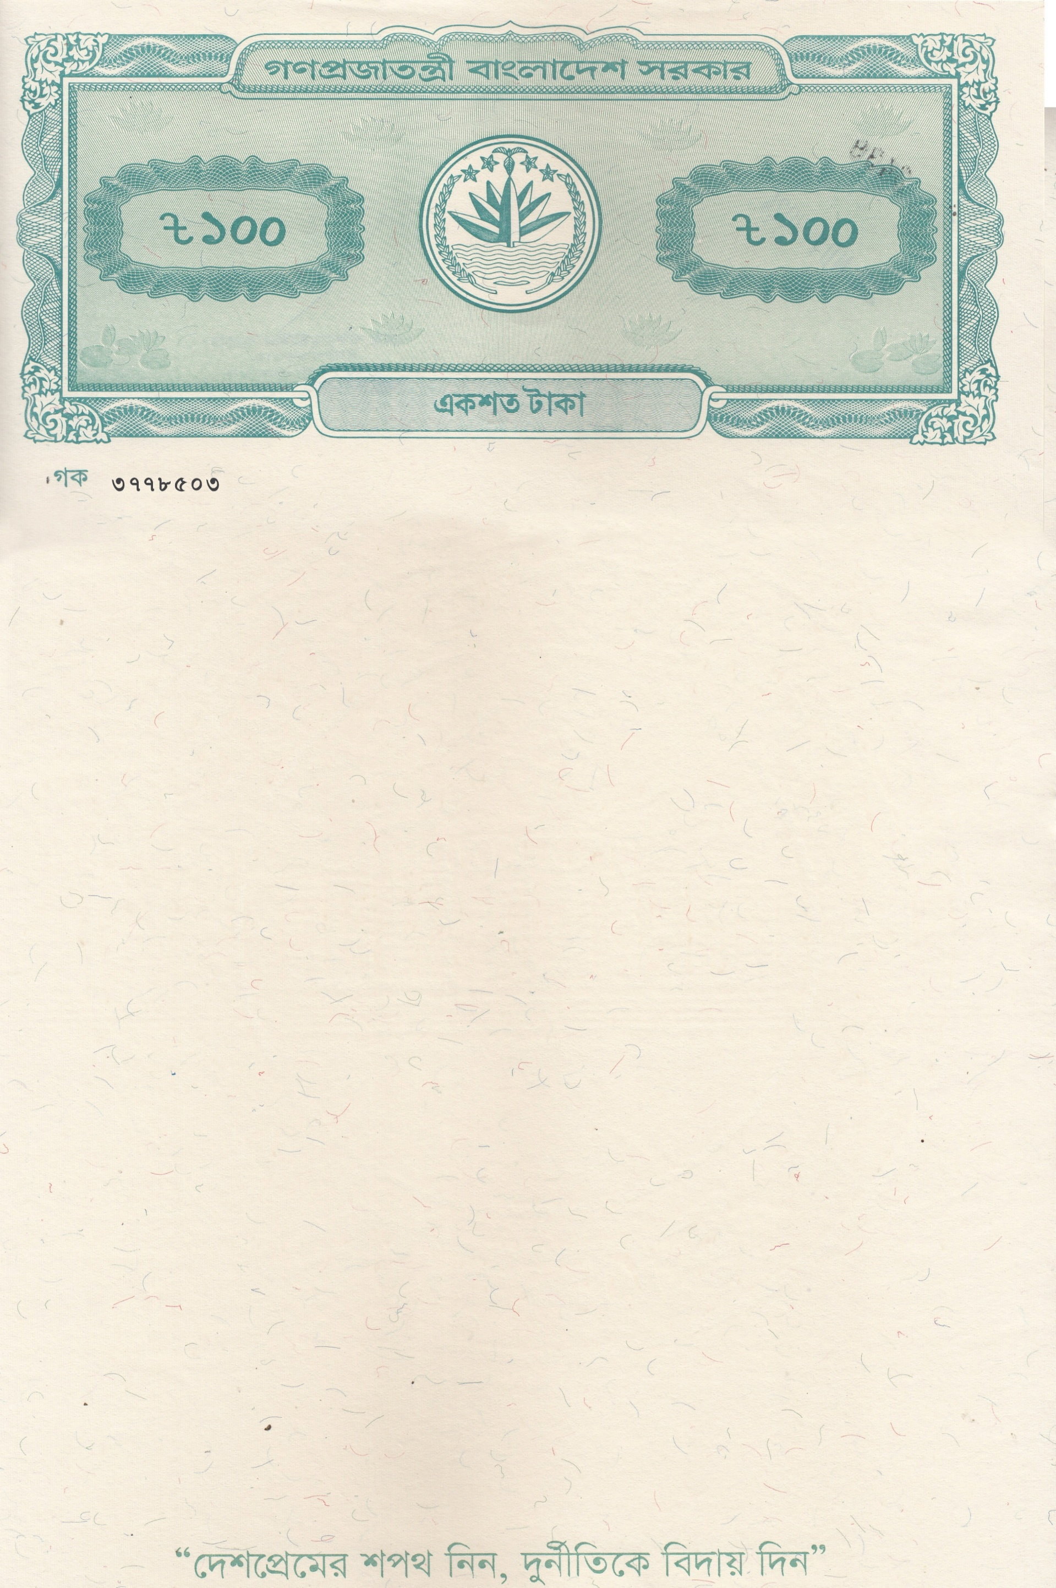
Page-02

- No illegal activity or illegal business is allowed in the House.

- After completing the period if the 2nd party’s likes to rent the House again then first party’s could rent to the 2nd party’s subject to fulfill his terms.

- The House is not allowed to use with anti-state activities or illegal trade, performing immoral, unsocial act. If such is done first party’s will not be responsible at anyhow. If any proof of doing such act is found the 2nd part will be compelled to leave the House with in 01(one) week.

- As soon as completing the term House will be vacated by the 2nd party’s in favor of the 1st party’s keeping it with previous state. If any expense arises for returning the House with previous condition 2nd party’s is to bear such expense.

- Tenant of the House is to allow new proposed tenant to see the House.

- Second party’s is to oblige maintaining procedure of using House taken by the House owner and should be careful to create any trouble for the other residents of the House.

Continue Page-3


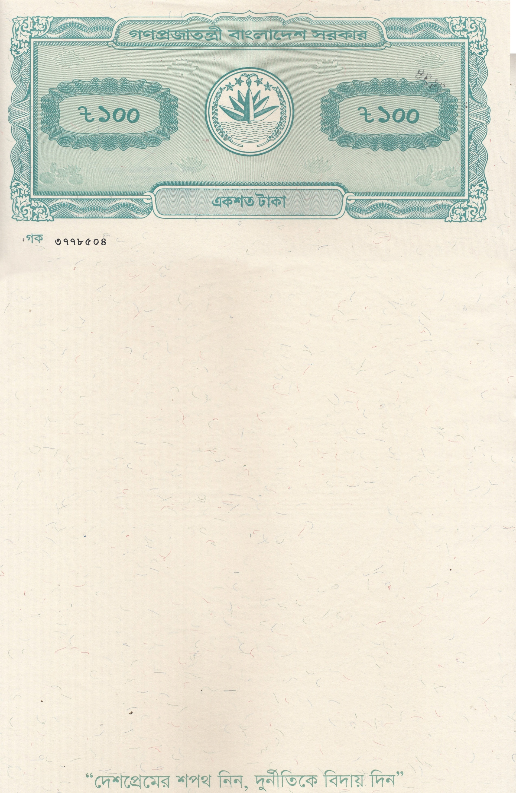
Page-03

In this regard, voluntarily, knowingly, in good health, and without any external provocation, having understood all the terms of the aforementioned rental agreement, I, the undersigned, hereby execute and sign this flat rental agreement in the presence of the witnesses.

This Deed of Lease Agreement is completed in three typed pages and attested by witness: WITNESS HEREOF the parties have signed this deed on the date, month and year mentioned herein above accepting the Terms and Conditions thereof.

Witness Signature:  1.  2.  3. | Signature:  First party/owner  Signature:    Second party’s/Tenant.



